**Learning Outcomes**

1. Custom ListView Control

**Custom ListView**

One of the most common controls in Android apps to represent list of data with pics and Info

Design customrow.axml which is just the single row of the list. You can design it the way you want.

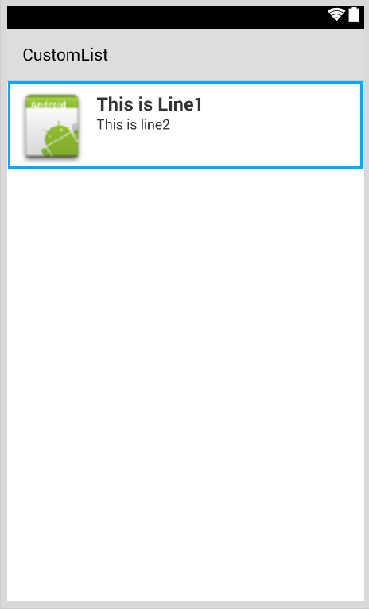

Image

Text2

Text1

<?xml version="1.0" encoding="utf-8"?>  
<RelativeLayout xmlns:android="http://schemas.android.com/apk/res/android"  
    android:layout_width="fill_parent"  
    android:layout_height="wrap_content"  
    android:padding="8dp">  
    <ImageView  
        android:id="@+id/Image"  
        android:layout_width="80dp"  
        android:layout_height="80dp"  
        android:layout_alignParentLeft="true"  
        android:layout_marginRight="8dp"  
        android:src="@drawable/icon" />  
    <TextView  
        android:id="@+id/Text1"  
        android:layout_width="wrap_content"  
        android:layout_height="wrap_content"  
        android:layout_alignTop="@id/Image"  
        android:layout_toRightOf="@id/Image"  
        android:layout_marginTop="5dip"  
        android:text="This is Line1"  
        android:textSize="20dip"  
        android:textStyle="bold" />  
    <TextView  
        android:id="@+id/Text2"  
        android:layout_width="fill_parent"  
        android:layout_height="wrap_content"  
        android:layout_below="@id/Text1"  
        android:layout_marginTop="1dip"  
        android:text="This is line2"  
        android:textSize="15dip"  
        android:layout_toRightOf="@id/Image" />  
</RelativeLayout>

Then you can design your main.axml, which contain the header and a listview.

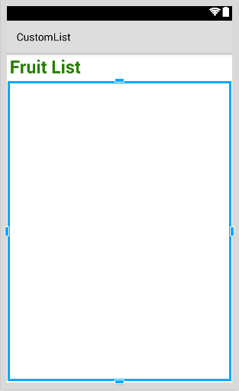

**Create a new class**

Data.cs

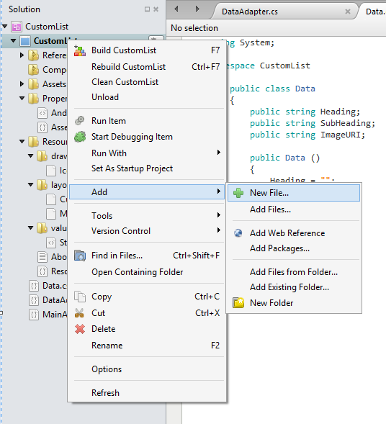

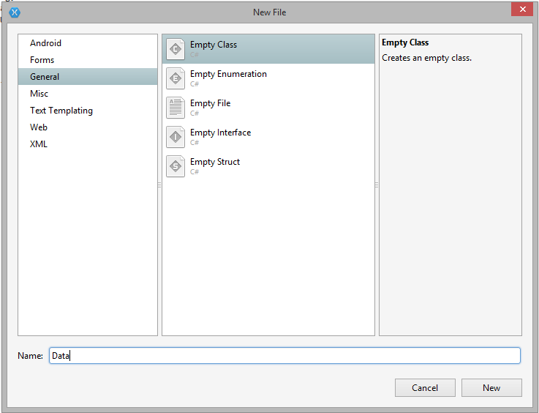

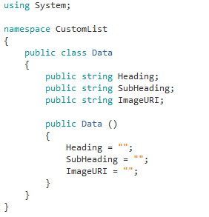

Every row in a listview represents an object of class Data.

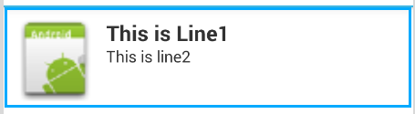

SubHeading

Heading

ImageURI

**Copy the DataAdapter.cs given to you**

In the get view function you do your modification for the custom row of your list.

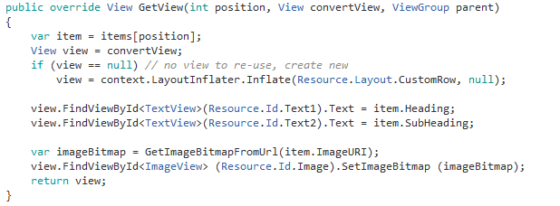

Linking the Data object with the custom row for list view

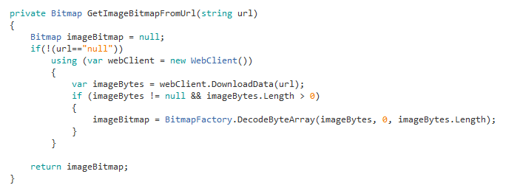

**MainActivity.cs**

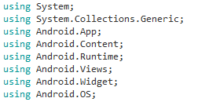

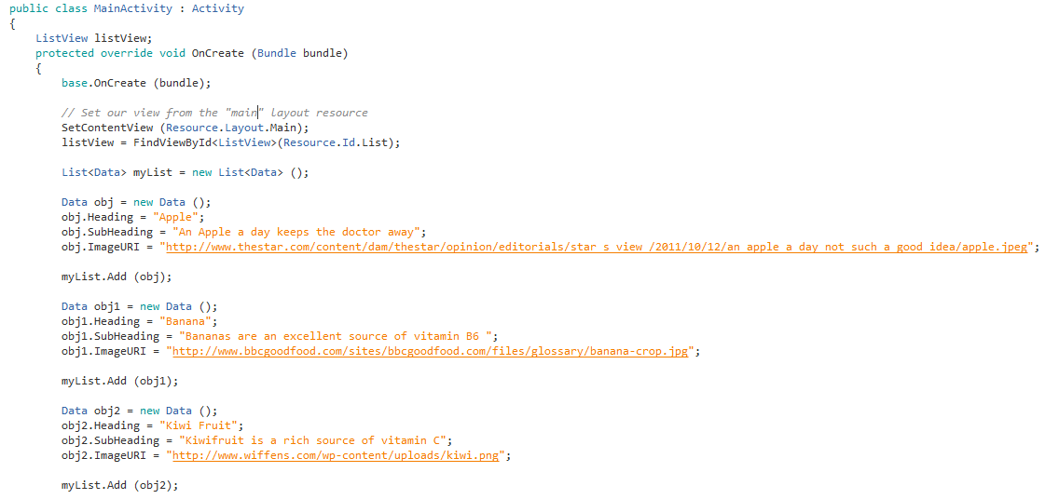

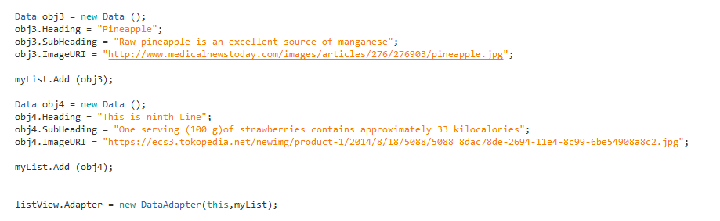

}

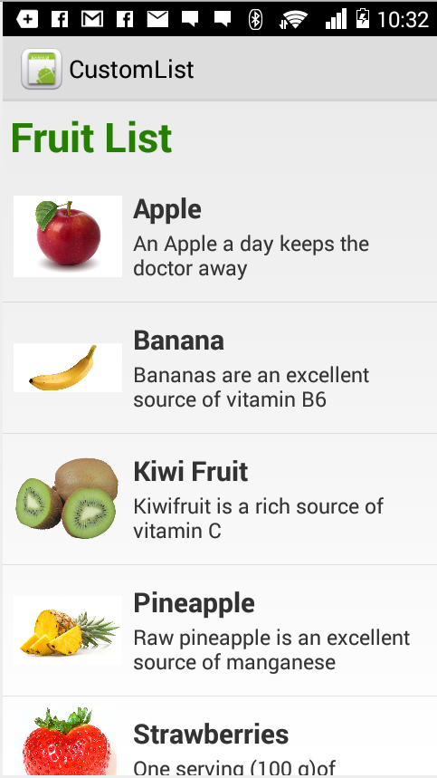

Obj2

Obj1

Obj

**Final Screen**

**Read Contacts**

Try and Implement a Custom ListView, listing all the contacts from your phone. The first line in the list shows the users display name, the second line is the phone numbers.

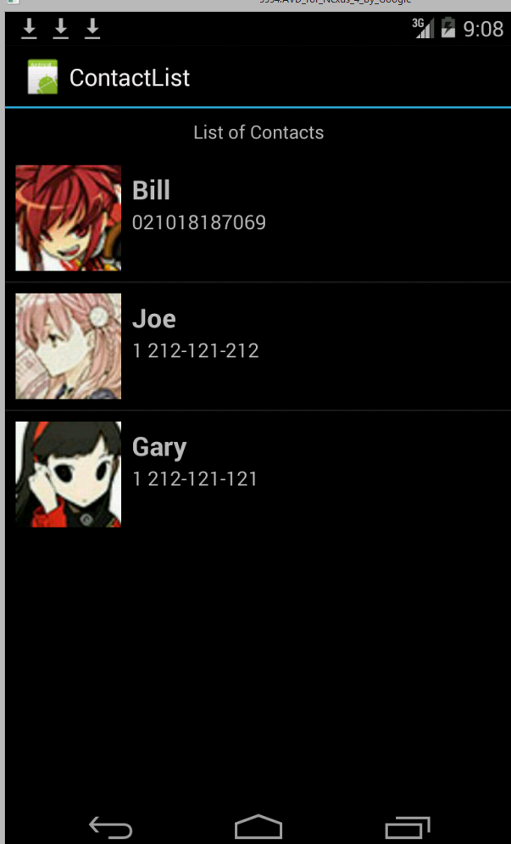

**In Components**

Import Xamarin.Contacts



**Permissions Required** (Project - > (Project Name) Options - > Android Application)

Read Contacts



**Solution**

**Data.cs**

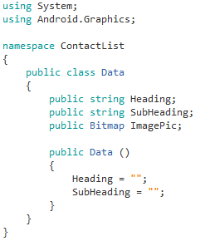

Note the change in the Data class with the Image URI replaced by the Image Pic.

**DataAdapter.cs**

**Modify the GetView function**

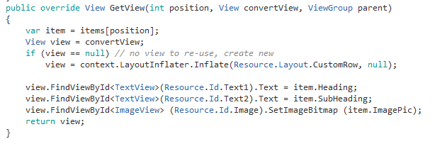

**MainActivity.cs**

